Exercise:

1. Write query that retrieve those cities of Customers where any supplier belongs to.

Solution:

use Northwind

SELECT DISTINCT c.City

FROM Customers c

WHERE EXISTS (

SELECT 1

FROM Suppliers s

WHERE s.City = c.City

);

Output:

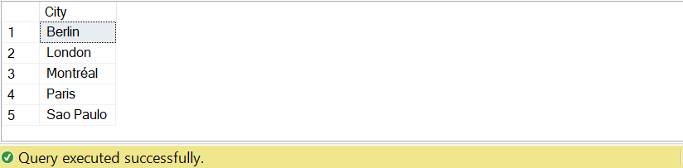

1. Write query that retrieve those cities of Customers where no single supplier belongs to.

Solution:

use Northwind

SELECT DISTINCT c.City FROM Customers c WHERE NOT EXISTS (SELECT 1 FROM Suppliers s

WHERE s.City = c.City );

Output:

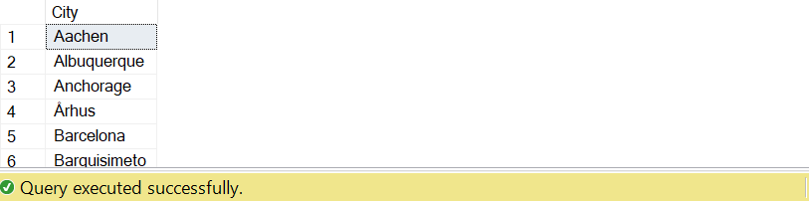

1. Write query that retrieve the regions of Employees and Suppliers.

Solution:

use Northwind

SELECT DISTINCT E.Region AS Employee_Region, S.Region AS Supplier_Region

FROM Employees E

JOIN Suppliers S ON E.Region = S.Region;

Output:

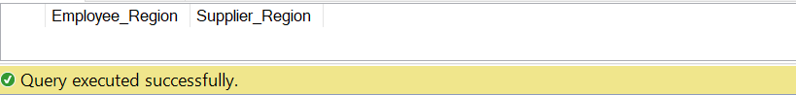

1. List distinct cities from of customers and suppliers, country must be Germany.

Solution:

use Northwind

SELECT DISTINCT City

FROM (

SELECT City, Country

FROM Customers

UNION

SELECT City, Country

FROM Suppliers

) AS Combined

WHERE Country = 'Germany';

Output:

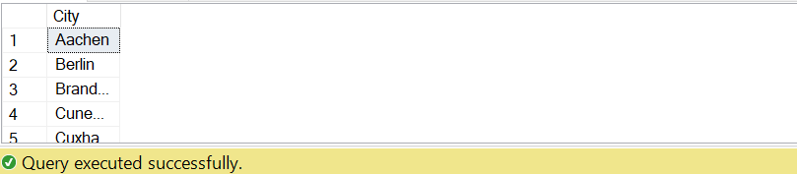

1. List all customers and suppliers (ContactName, City, and Country).

Solution:

use Northwind

SELECT ContactName, City, Country

FROM (

SELECT ContactName, City, Country

FROM Customers

UNION ALL

SELECT ContactName, City, Country

FROM Suppliers

) AS Combined;

Output:

